The Picture Word Inductive Model in the Visual Arts Classroom
Devin Allen
Endicott College

Abstract
This lesson explores how the Picture Word Inductive Model, originally designed for teaching reading and literacy can be employed in the visual arts classroom. The students in this lesson are studying the interdisciplinary nature of learning as illustrated by the relationship between the visual and literacy through symbols, and visual arts and mathematics. The students employed the Picture Word Inductive Model to examine three paintings from the Northern Renaissance use their constructed understanding for further work in the unit.

Introduction
The Picture Word Inductive Model (PWIM) was developed by Emily Calhoun as an inquiry-based model for teaching reading and literacy which is relatively new in its development and use (Joyce, Weil & Calhoun, 2015; Loh, 2012). This lesson will explore its use in the visual arts classroom. In an Art I course, students will use the model to examine Northern Renaissance paintings to first, connect prior learning from earlier in the unit; second, provide an opportunity to develop a more sophisticated understanding and use of the concepts in this unit, and third, introduce previously unstudied concepts that are important to visual arts.
Model of Teaching
PWIM is using an image to elicit first identification, then classification of visual stimuli in written form. While initially intended to develop reading and literacy in in primary school, it has applications beyond, and this lesson aims to illustrate this. It relies on a constructivist model of learning and provides students with opportunities to inquire about what they see and to create meaning about it (Joyce, Weil & Calhoun, 2015; Loh, 2012: Stehle, 2010). Students are able to understand the model and use it on their own very quickly (Loh, 2012). Students stay alert for words and concepts that help them categorize the world and one of the key procedures of PWIM is to categorize (Joyce, Weil & Calhoun, 2015: Westermann & Mareschal, 2014). Studies show that both imagery, and image words improve the vocabulary in students which is naturally applicable to the visual arts.
If we accept the schema theory of learning, where students organize information and retain it better when it connects to prior learning, this model is an excellent way to discuss the use of symbols and mathematics in visual arts (Stehle, 2010). The students have already been exposed to some of these concepts and creative thinking is enhanced by the acquisition and use of prior learning (Milbrandt & Milbrandt, 2011).
Lesson Setting and Lesson Objectives
The goals of this lesson are three-fold: To build upon and expand the student’s prior knowledge of the use of mathematics and symbols in painting, to provide a wider understanding of art history, in this case Northern Renaissance painting, and to introduce design concepts and terminology relevant to the first two objectives. All of these are important because students need to be able to understand the common terminology we use when both discussing the visual arts and creating individual work (Gochet, 2010). Furthermore, it will allow them to use the tools of categorization in acquiring understanding that can be applied to future learning activities (Westermann & Mareschal, 2014).
In this unit the students have looked at some introductory examples of how symbols are used in visual arts and discussing the wider definition of symbolism in painting. They have also examined the use of the colour wheel, a mathematical system to choosing colours when making a design. The class took a trip to the Forbidden City to collect images of the use of symbols in traditional Chinese art as well.
The classes are Art I studio courses consisting mostly of ninth graders. The school is a large, international school in a northern city in China. Students come from a fairly affluent background, are passport holders from the USA, Canada, Korea, and The Philippines, and a majority are of East Asian or Southeast Asian ethnicity. Students in this course are interested in visual arts and some take the photography and film classes as well.
The unit is about interdisciplinary learning as illustrated through the use of mathematics and symbols in painting. The lesson in which the PWIM was used, gave the students the protocol to identify and classify the use of symbols and mathematics in Norther Renaissance painting. The students had one, whole class application of PWIM, one small group, and were challenged with one more application on their own.
Preconference
For the observation process the studio manager acted as observer. She is currently working towards an MFA in studio art and has intensions on being an art teacher. She has been the studio manager for the past two years, works across middle and high school, has attended team meetings when they pertain to pedagogy, and has taught some lessons to our classes in digital media applications. In our pre-observation meeting we discussed the unit’s enduring understandings, essential questions, knowledge, and skills. PWIM was explained for theory and how it would be used in class. She was provided some of the questions from the peer coaching guides. First, to make a general observation of the class, did they appear to understand the goals of the lesson and how it relates to the enduring understanding as well as our knowledge and skills. Second, she was asked to watch for how students applied the model through the guided and small group work looking for how students adopted the model and how comfortable they felt with using it. Finally, asked her to watch for how well the students could make the skills transfer when we began discussion the principles of design.
Lesson Activities
First, the students were presented with Frans Synders’s The Fruit Stall, projected on the board and given an A3 sized, colour copy. They students identified everything they saw in the painting on their own and after five minutes described what they saw while the teacher labelled the image on the board using Art-o-Matic, a Draw.io application. After five minutes the students were informed there are two categories of symbols being used, primary and secondary. The primary category includes the physical senses, the seasons, and elements (water, air, fire, earth). They grouped the symbols according to these categories individually or with partners. The students were then informed of the secondary category of symbols and told that some images may be in both categories. These are religion, respect, positivity, and peace. The students then work in small groups or on their own categorizing the symbols again. Third, the students created a title for the painting and wrote it on their copies. Fourth, the students were shown a website which explains the painting in full and ask the students made notes on their copies or sketchbooks.
The students now tried it on their own. They are presented a Dutch still life from the same time period, Jan Janz, van de Velde III’s Still life with Tall Beer Glass. The PWIM protocol is projected on the board and students have time to work through the steps. About ten minutes in they are told the Flemish painters (The Fruit Stall) of the time aimed to reflect a positive approach to living life, while the Dutch (Still Life with Tall Beer Glass) painters aimed at warning people from falling into disrepute. Once the students have worked for another five minutes, they were presented with a website which explains Dutch Renaissance paintings in general, called Vanitas, and challenged them to identify the meaning of the symbols in this painting. All of these websites are linked on the schools learning management system. At the end the students share their titles with the class.
Finally, students are presented with terminology for the principles of design: Rhythm, balance, symmetry, unity, and variety and challenged to use the PWIM to identify each. These terms and concepts have not been explicitly explored in the class to date.
Post Conference
After the initial lesson the observer gave her impressions on the observation prompts. She saw that the students were able to apply the model, but their initial work was very superficial. The items they observed did not do a good job of understanding what the painting was about. When it came time to classify the symbols, the students often went with their immediate, intuitive responses and the observer felt that the goal of identifying and understanding the use of symbols, while entertaining, was missing some of the understanding behind it. However, as we moved into the second classification of symbols, they started to become more adept at seeing meaning in the paintings became deeper thinkers about the meaning and, while using the model, did so unconsciously.
Analysis
Initially students were hesitant to speak in class although as time progressed, they became more comfortable. Not only were they describing what they saw, they were also asking questions about certain parts of the image. Already connecting prior learning to these new stimuli. For example, there were questions about why that watermelon-like object was white, and if pinecones could be that large. As the students were introduced to the primary and secondary themes, they were able to make connections to what they knew, or thought they knew about symbols in the Renaissance and sometimes even connecting the symbols to things they learned about in other classes and stories. This is an excellent example of using the schema theory of learning as well as providing an opportunity to construct their own knowing about the use of symbols (Joyce, Weil & Calhoun, 2015; Stehle, 2010). In one of the two classes this created a great deal of excitement and by the end of the first round were skipping ahead to the research even though they had the protocol in front of them, proposing titles for the painting. PWIM proved to be a good way to encourage students to construct their own meaning, an important factor in visual art education (Milbrandt & Milbrandt, 2011).
Vocabulary construction was less efficient. While the students definitely acquired art history knowledge, a class or two later they could not remember the term Vanitas although, they knew these types of paintings have a name. They also did not recognize the use of colour theory (mathematics) in the paintings. Fortunately, when taught the golden section, another mathematic theory, they did recognize it in their independent, formative, PWIM assignment. Acquisition of the principles of design, also required further instruction and reinforcement in later lessons. Most likely, students could use the PWIM to understand these terms; however, PWIM was employed as part of a variety of teaching models in this unit which included synectics and explicit instruction.
PWIM can be a very useful and engaging tool in the visual arts classroom. It can be used in conjunction with other activities that aim to teach concepts and language. The students summative work, which has not been completed as the writing of this paper, very likely will show a more sophisticated use of language and acquisition of concepts. PWIM does require a good deal of set-up but yields valuable results in the visual arts classroom.
References
Gochet, Paul. (2010). Ontology and metaphysics in word and object. Nouvelle Série 53(212). Pp, 387 – 398.
Joyce, B., Weil, M., & Calhoun, E. (2015). Models of Teaching. Tokyo: Pearson.
Loh, Jason. (2012). “Shaking” and learning. The Reading Teacher 65(7). P. 460.
Milbrandt, Melody., and Milbrandt, Lanny. (2011). Creativity: what are we talking about? Art Education 64(1). Pp 8 – 13.
Stehle, Andrea. (2010). The role of study time and method on vocabulary learning and retention: An action research study. The Classic Outlook 88(1). Pp 18 – 21.
Westermann, Gert., and Mareschal, Denis. (2014). From perceptual to language-mediated categorization. Philosophical Transactions: Biological Sciences, 369(1634). P. 1 – 10.

Appendix
Paintings
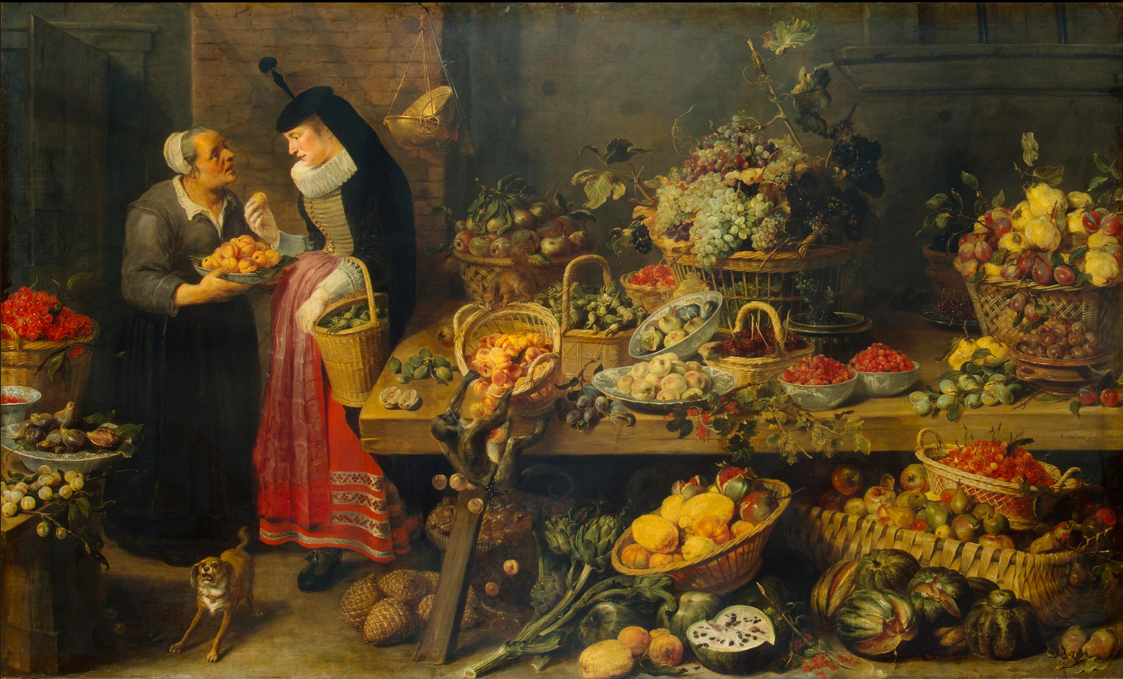
Synders, Frans. (1681 – 1621). The Fruit Stall. St. Petersburg: The State hermitage Museum.
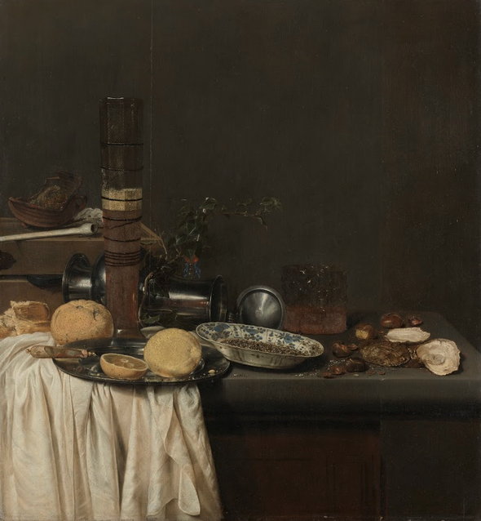
van de Velde III, Jan Janz. (1647). Amsterdam: The Rijksmuseum.
Student Work
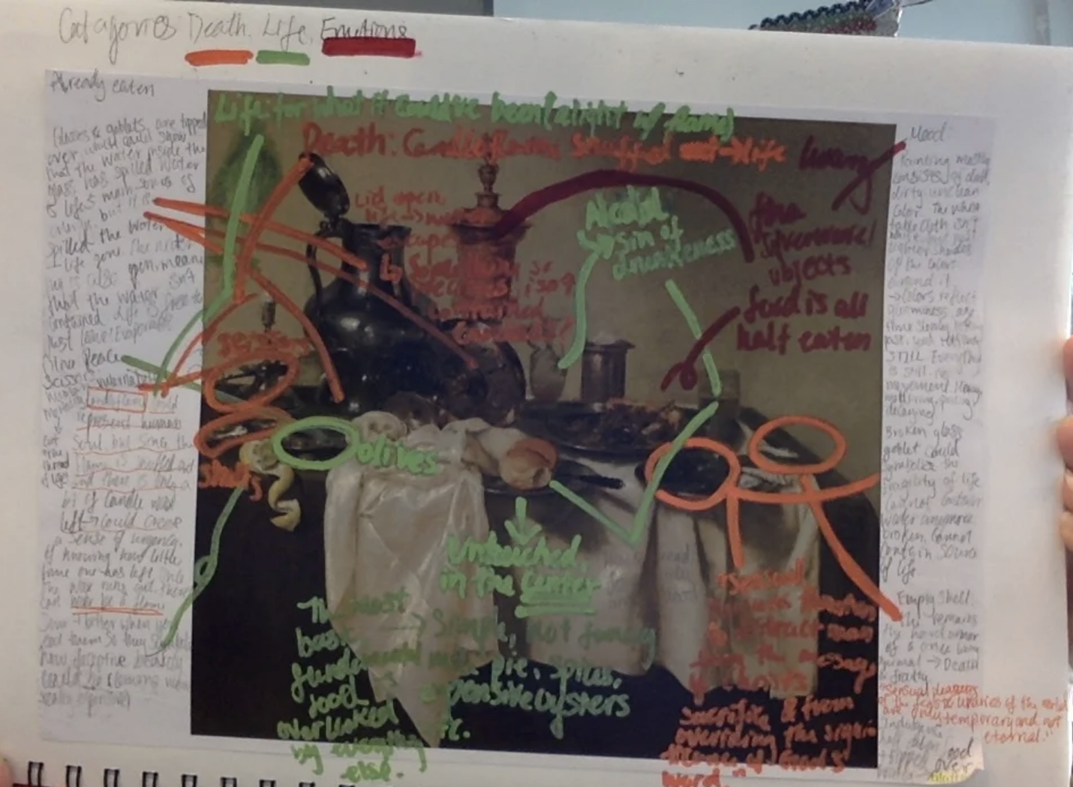
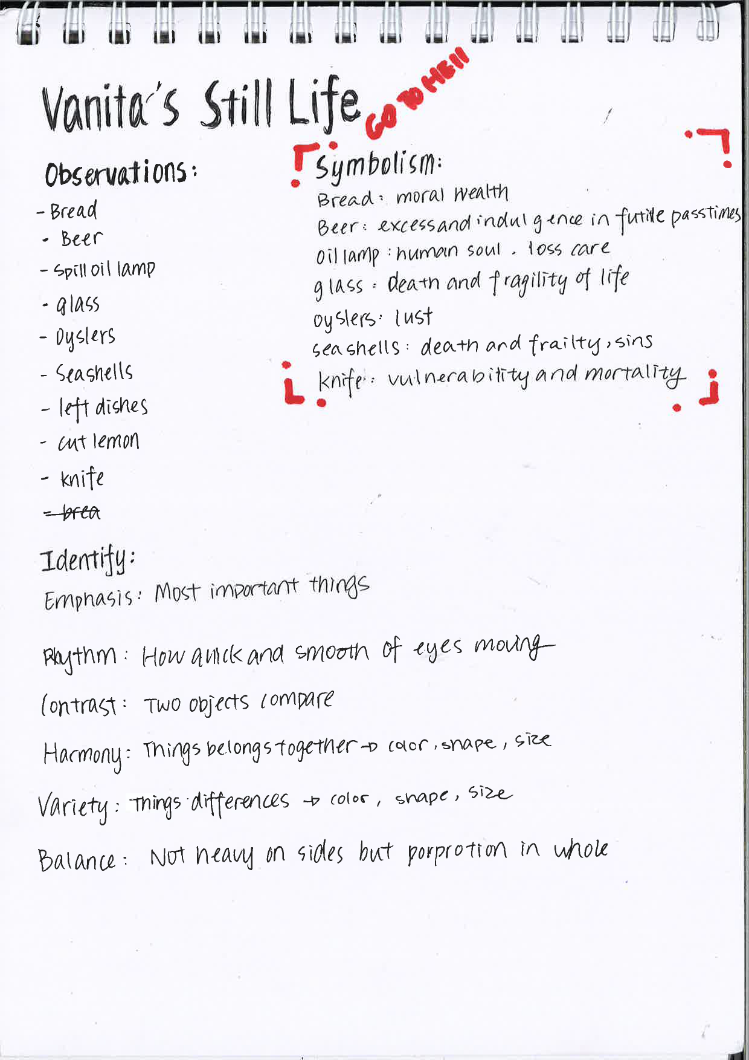
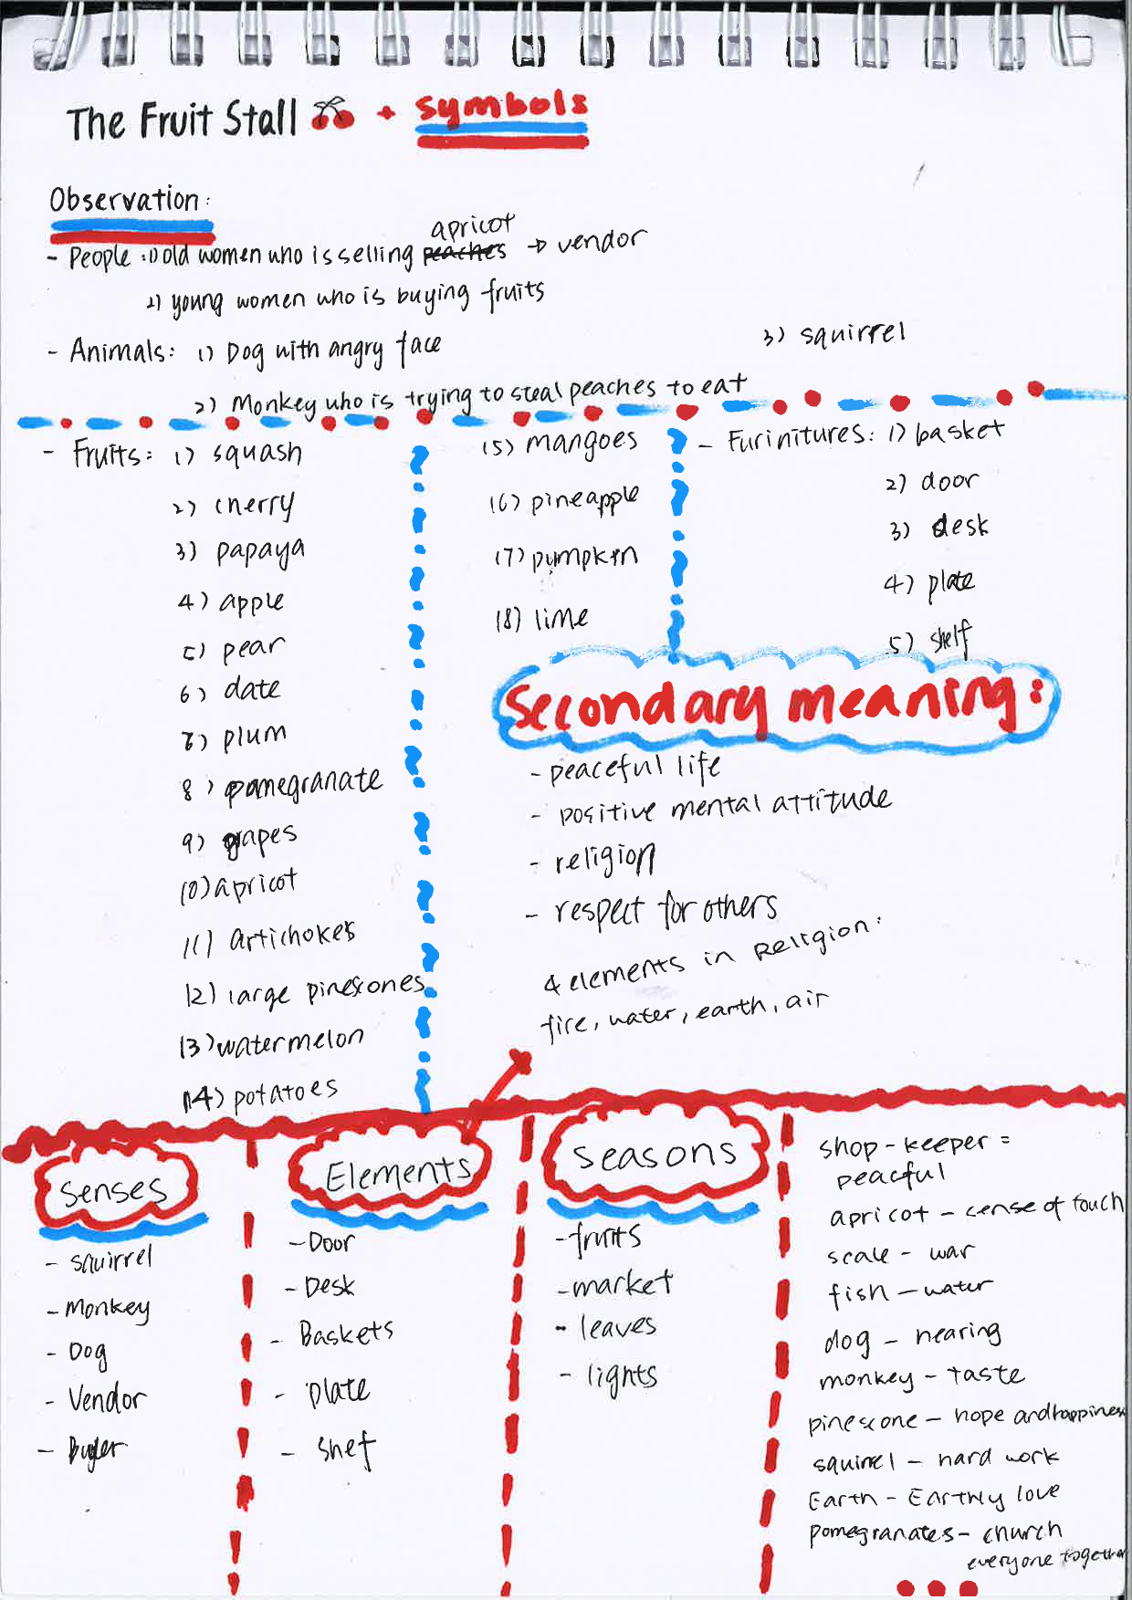
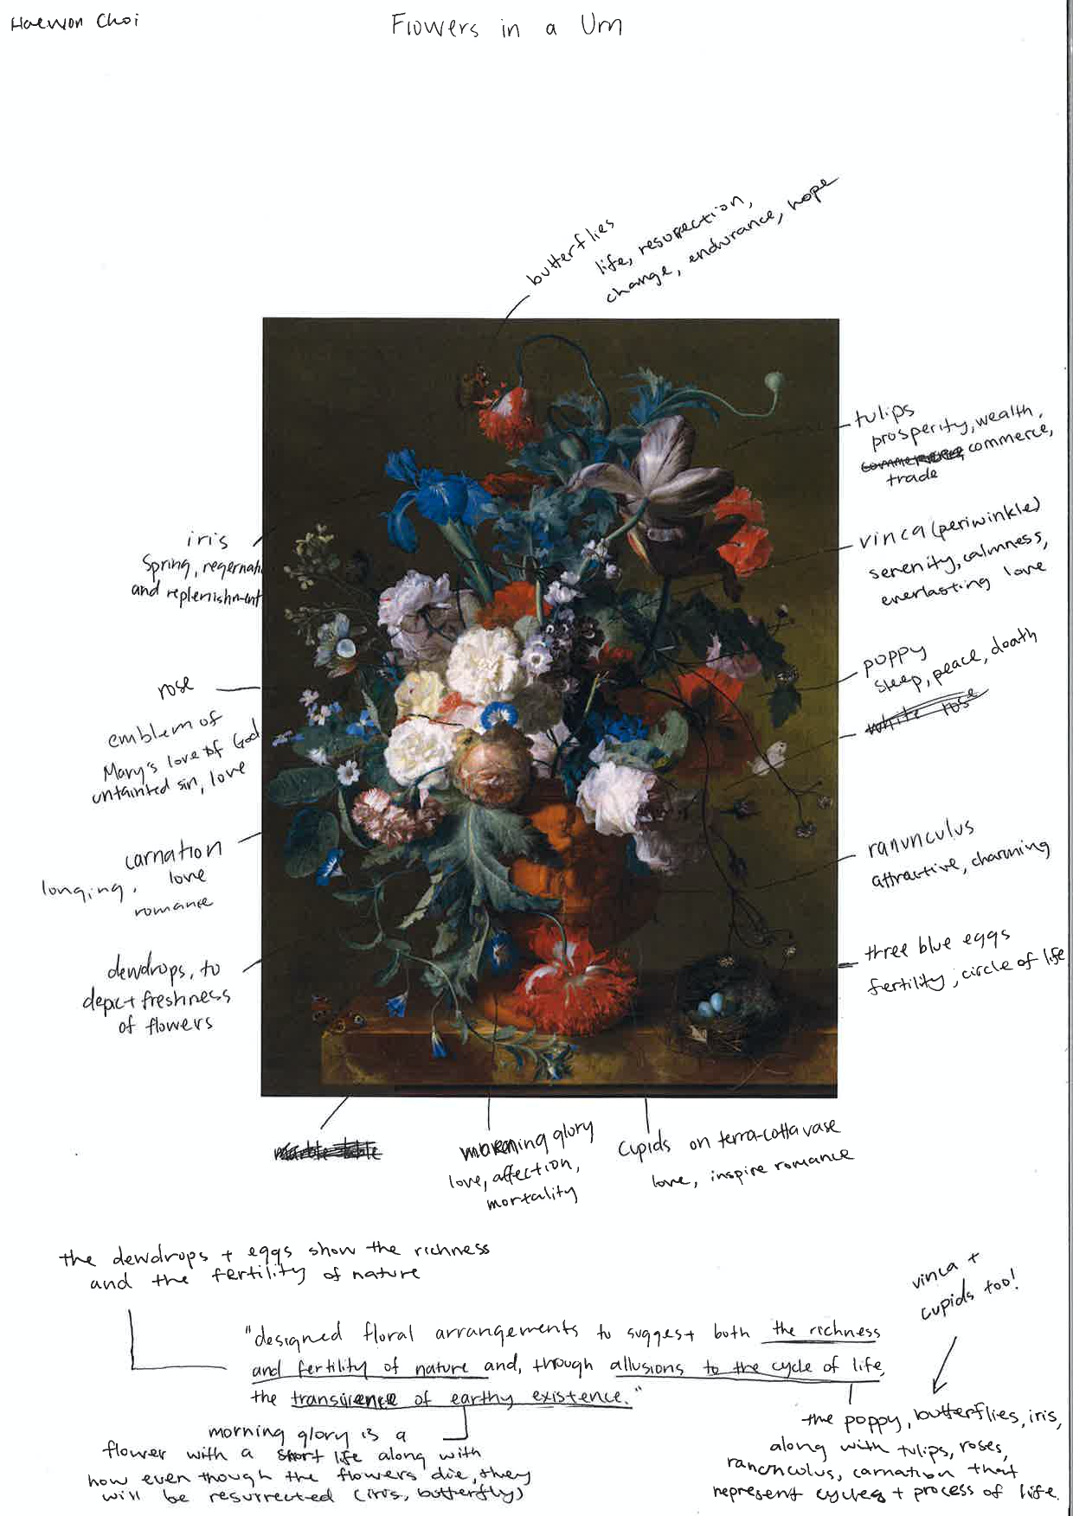
PWIM Peer Coaching Guide
- Describe your picture – See Appendix Paintings
- List of words shaken out of the painting.
  - Very many, students described everything they saw, categorized them into type, then categorized them into teacher-suggested lists: Senses, elements, seasons; and Positivity, peace, respect, and religion.
  - The Vanitas paintings have different categories, you can see from the submitted images that the students developed categories unique to each work of art.
  - Sometimes the students developed categorizations that are different from accepted, art history conclusions, but the value of classification and create meaning are also important learning activities for students
- Examples of categories generated by students: Resurrection, hope, love, sin, hard work, death, frailty, and so much more.
  - This is only what is represented in the appendix. Sixteen students completed this exercise and the categories and representations are unique to the student.
  - Other students do note colour combinations as well as comparisons to traditional, Chinese art.
  - As students are developing their own artwork, they are using some of the conventions accessed through here.
- Examples of categories or concepts selected by you for instructional emphasis:
  - A painting can use images to communicate meaning.
  - Structure of a painting can be made harmonious through application of mathematic principles.
  - An artist’s use of accepted and invented symbols make an artwork interesting.
- Examples of titles generated by students.
  - The Happy Life
  - Eat a Shell, Go to Hell
  - It looks pretty but it isn’t all that.
- Examples of sentences generated by students.
  - Designed floral arrangements to suggest the richness and fertility of life, and allusions to the cycle of life and earthly existence.
  - The water in the glass represents what we have of life and the spilled water is what we waste of life.
- One of the informative paragraphs composed by you from student ideas. We didn’t use this activity in our lesson, although there was paraphrasing of student ideas as they were being developed.

